亚马逊CDQ 6个核心指标 权重讲解
本文主要讲解亚马逊CDQ核心指标，以及Sub Category Score
CDQ主要是指亚马逊综合数据质量 Amazon Composite Data Quality，重点6个指标

CDQ
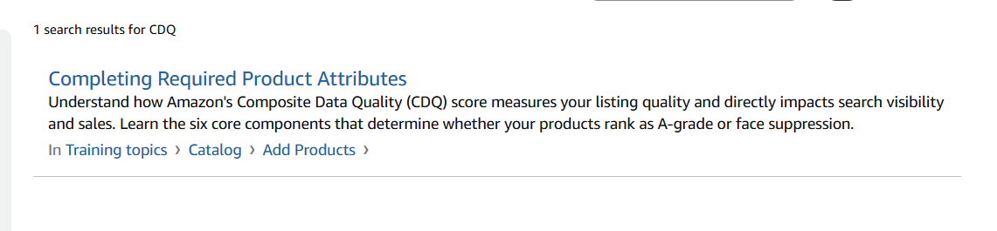
CDQ composite data quality score
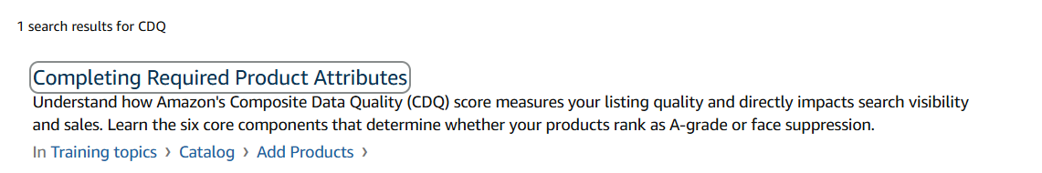
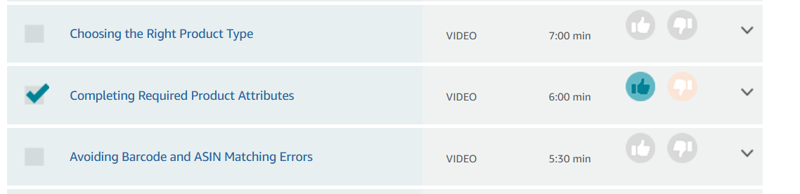
How do I improve my CDQ score? Issue: Recommended Attributes guidelines
CDQ SCALE for ASIN:To improve your catalog data quality score, focus on completing missing product attributes and ensuring accurate information. Here's how:
Access listing quality recommendations:
- Go to Items and select Catalog
- Under the Recommend next step drop-down, choose Improve listing quality
- Use page views to prioritize which products to update first
- For each product, click improve listing quality to open a side panel, fill in missing information, and click Save changes

For bulk updates:
- Go to Items > Catalog and click Improve listing quality in bulk
- Select Generate report to download ASINs missing attributes
- Complete the file with missing attribute values and upload it back

Key areas to verify:
- Ensure product identifiers (UPC, EAN, GTIN) are unique and match physical barcodes
- Verify case pack attributes match your physical shipments (check Package level and Items per inner pack under the Catalog Shipping tab)
- Add recommended attributes to improve discoverability, enable product comparison features, and potentially reduce returns
You can also use the Catalog insight tool to analyze customer feedback and optimize your listings.
Link to catalog insight tool- https://vendorcentral.amazon.de/sgh/VendorGrowthAnalytics

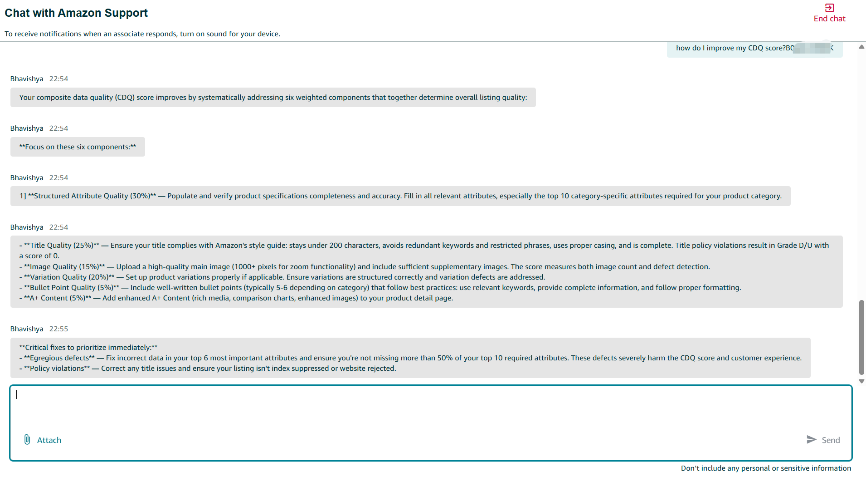
Your composite data quality (CDQ) score improves by systematically addressing six weighted components that together determine overall listing quality:

Focus on these six components:

1] Structured Attribute Quality (30%) — Populate and verify product specifications completeness and accuracy. Fill in all relevant attributes, especially the top 10 category-specific attributes required for your product category.

- Title Quality (25%) — Ensure your title complies with Amazon's style guide: stays under 200 characters, avoids redundant keywords and restricted phrases, uses proper casing, and is complete. Title policy violations result in Grade D/U with a score of 0.
- Image Quality (15%) — Upload a high-quality main image (1000+ pixels for zoom functionality) and include sufficient supplementary images. The score measures both image count and defect detection.
- Variation Quality (20%) — Set up product variations properly if applicable. Ensure variations are structured correctly and variation defects are addressed.
- Bullet Point Quality (5%) — Include well-written bullet points (typically 5-6 depending on category) that follow best practices: use relevant keywords, provide complete information, and follow proper formatting.
- A+ Content (5%) — Add enhanced A+ Content (rich media, comparison charts, enhanced images) to your product detail page.
Critical fixes to prioritize immediately:
- Egregious defects — Fix incorrect data in your top 6 most important attributes and ensure you're not missing more than 50% of your top 10 required attributes. These defects severely harm the CDQ score and customer experience.
- Policy violations — Correct any title issues and ensure your listing isn't index suppressed or website rejected.
Bhavishya官方解答：
The first 6 RAI attributes are the top 6 most important product attributes for your specific product type, identified by a Natural Language Processing (NLP) model called Relevance Attribute Index (RAI).

Band A attributes :
- Help identify and describe the essential nature of the product
- Describe fundamental characteristics that identify the product's core attributes
- Differentiate the product from other similar items
- Examples: For a laptop, this might include processor type, RAM, operating system, or display size

Band B attributes :
- Key product characteristics that differentiate between variants and versions of the same product type
- Allow customers to select their preferred option
- Attributes that differentiate between similar products
- Examples: For a laptop, this might include color, connectivity options, or specific port types
Together, Band A and B attributes form the "Depth Widget" — the detailed information visible on the product detail page that helps customers make informed purchasing decisions.

The first 6 RAI attributes are NOT fixed — they vary by product type. They are determined by the Relevance Attribute Index (RAI), an NLP model that ranks attributes differently for each category based on customer behavior.

What makes them "first":
The RAI model ranks all attributes for your product type (1st, 2nd, 3rd, etc.) based on which attributes customers care about most. This is determined by analyzing:
- Customer reviews
- Customer Q&A conversations
- Search queries
- Product titles and descriptions
- Manufacturer and competitor websites
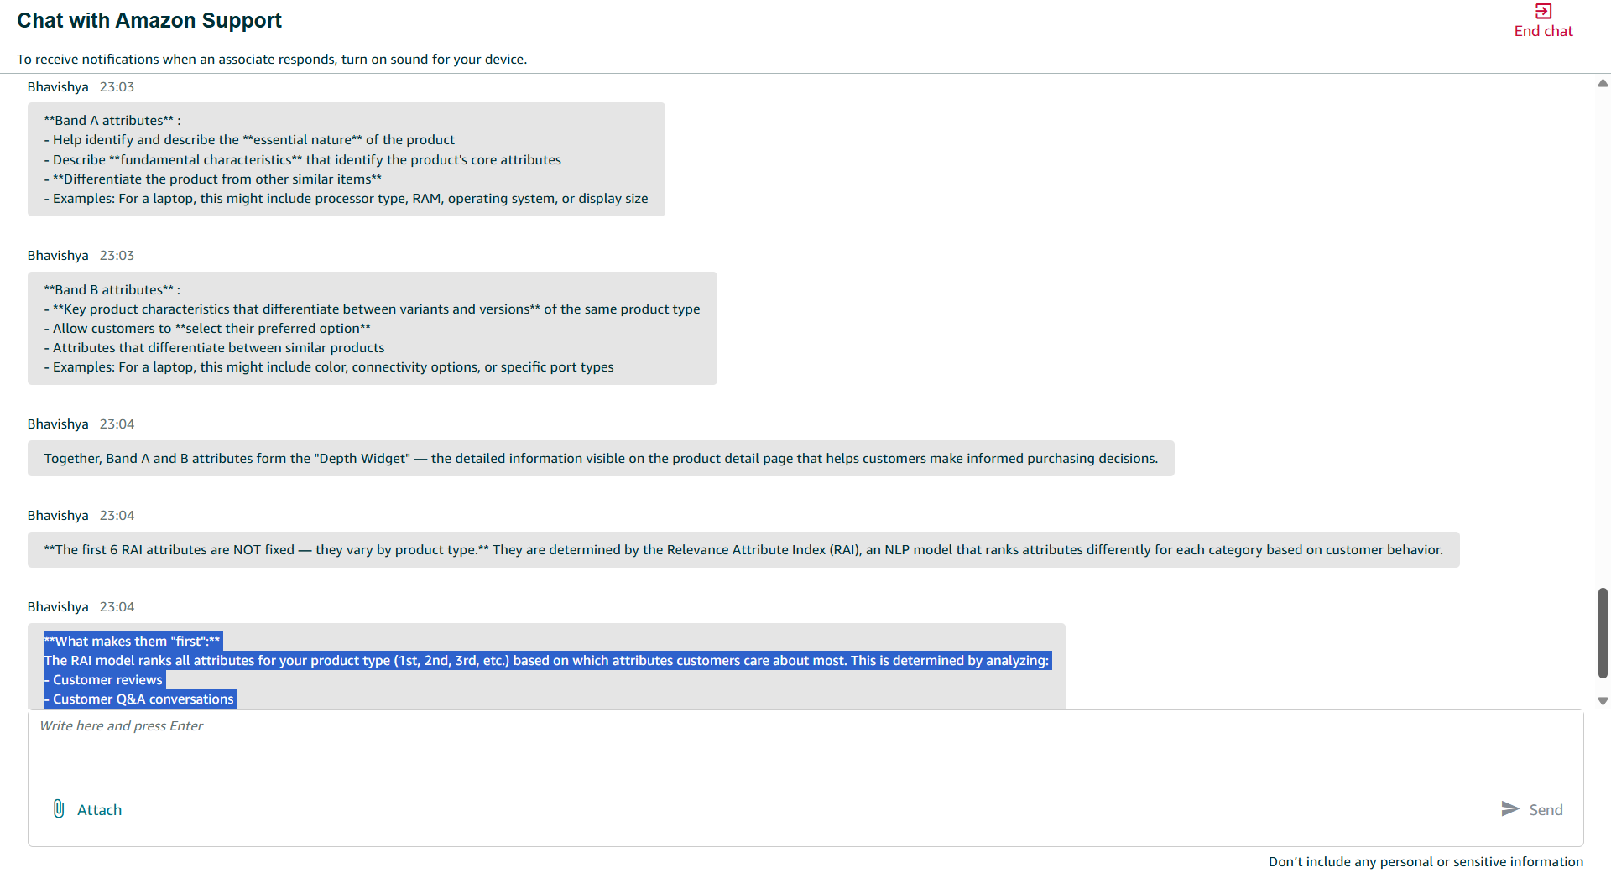
Bhavishya
23:10
Discoverability refers to initiatives focused on helping customers find products through search and browse experiences. It involves:
- New Product Launch (NPL) Discoverability — A structured process to ensure new products are discoverable and visible to customers during launch
- Tracking key metrics across the customer funnel: Traffic (Glance Views per 100k customers)
Consideration (Add-to-Cart/Glance Views)
Conversion (Units/Glance Views)
- Tools like DART (Discoverability Analytics & Research Tool) — Provides insights into what customers are looking for from a search perspective and identifies attributes that require enrichment

For New Product Launches, the process includes:
- 6-12 months pre-launch: Submit NPL details and develop launch strategy
- Attend SAS Discoverability Office Hours (if Priority 1 or 2)
- 4-6 weeks prior: Submit A+ Content, enroll in Vine
- Launch day activities: Walk the store, ensure search/display campaigns are running
Product Type Classification is the system that determines the category/product type for an ASIN. Key points:
- Not yet launched in all marketplaces — For example, PT Classification is not yet launched in IE (Ireland) marketplace
- The classification affects how products are organized, searched, and filtered on Amazon
ETATBD stands for "Estimated Time to Availability"
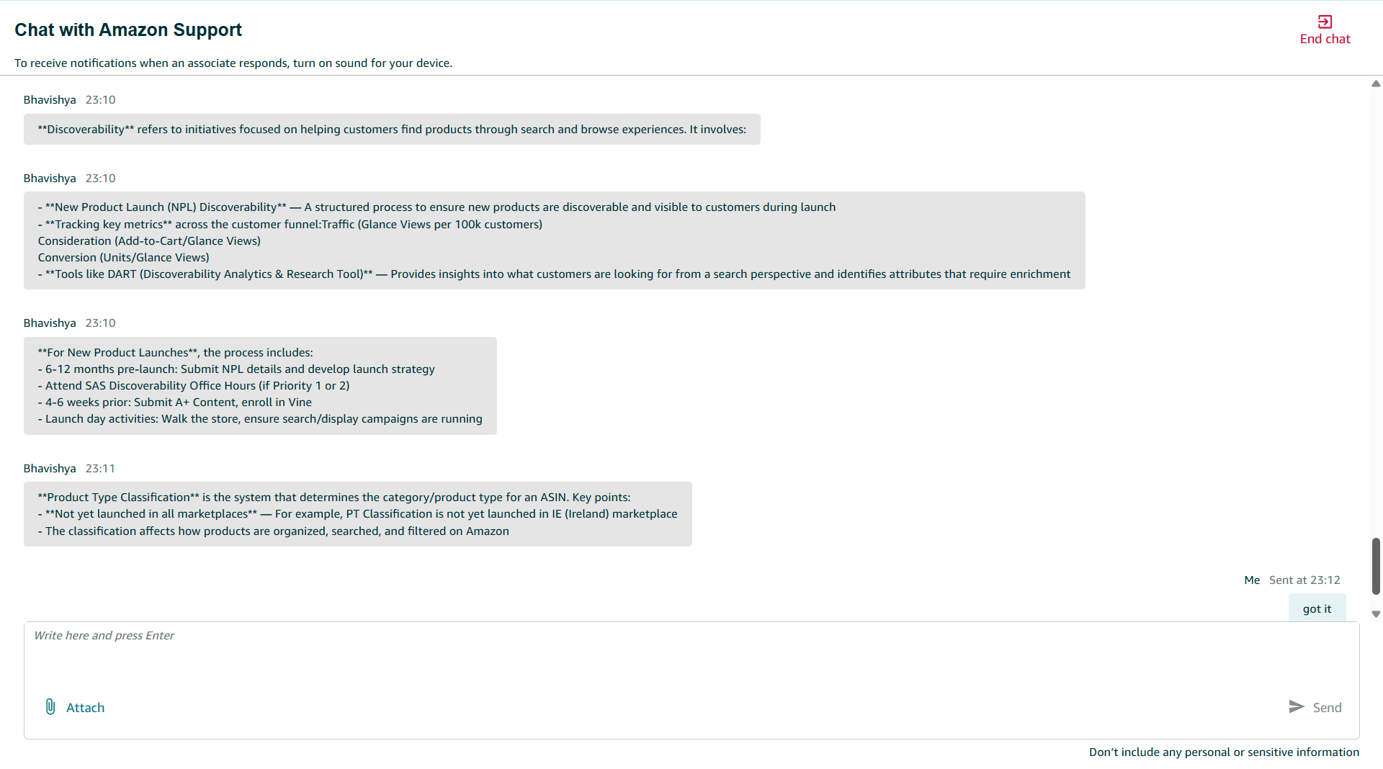
"N/A weight" in the context of CDQ refers to components that are not applicable to certain ASIN types. Here's the breakdown:

Variation Quality — 20% Weight (or N/A for Orphan ASINs)
Component Variation ASIN Weight Orphan ASIN WeightVariation Quality20%N/A (redistributed)
What this means:
- Variation ASINs (products that come in different options/sizes/colors) — Variation Quality is evaluated at 20% weight
- Orphan ASINs (standalone products NOT in a variation family) — Variation Quality is N/A because it's not applicable
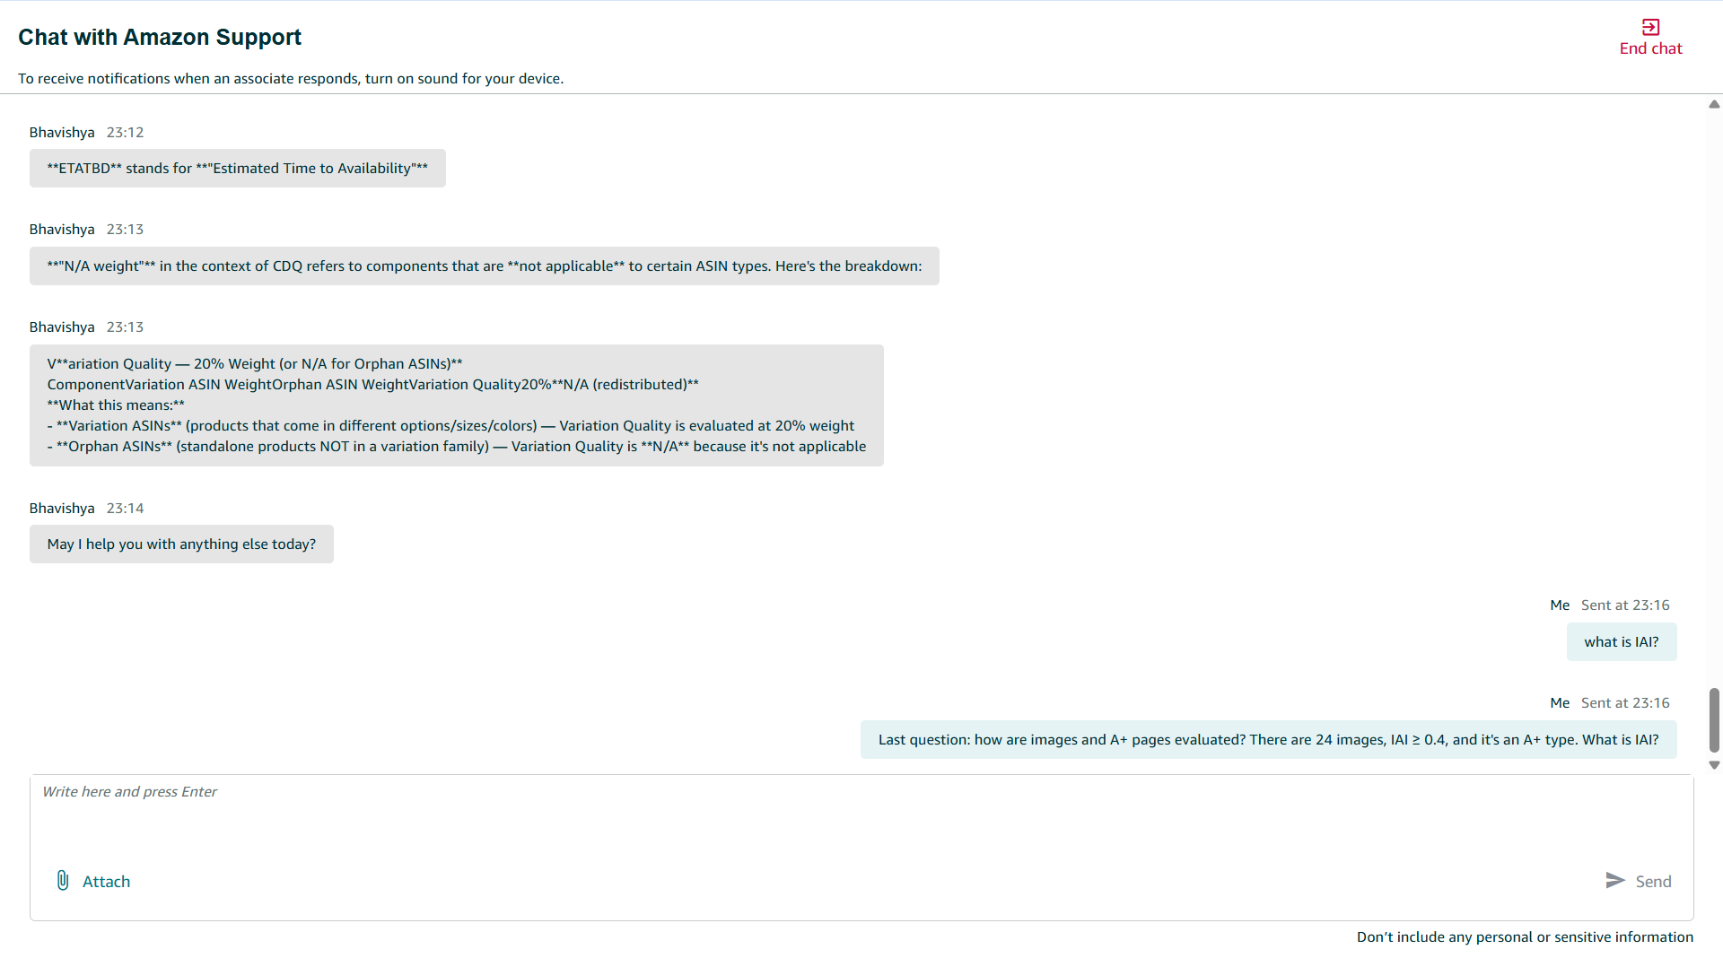

here's how images and A+ pages are evaluated in CDQ:Image Quality Evaluation (15% weight / 18.75% for orphans)
How your 24 images score:
Your ASIN has 24 website-active images, which exceeds the 4-image minimum. The Image Quality score depends on whether there are any image defects:
ConditionScoreImage count ≥ 4 AND **no image defects1.0 (100%)**Image count ≥ 4 AND **has image defects0.4 (40%)**Image count < 4 AND no defects0.6 (60%)Image count < 4 AND has defects0.0 (0%)
Since you have 24 images (far exceeding 4), your score is either:
- 1.0 — if no image defects are detected
- 0.4 — if any image defects exist
IAI stands for Imaging Attribute Index — a metric that measures the quality and completeness of product images on your catalog.
IAI stands for Imaging Attribute Index — a metric that measures the quality and completeness of product images on your catalog.

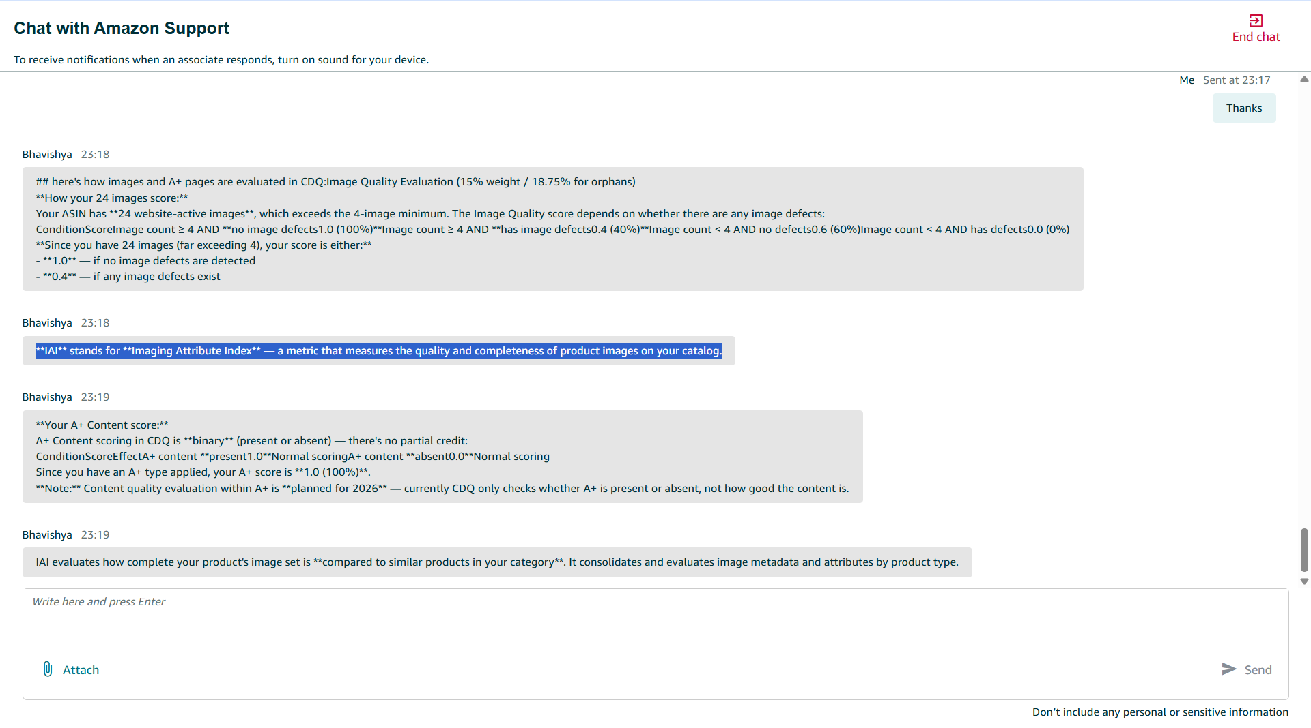
Your A+ Content score:
A+ Content scoring in CDQ is binary (present or absent) — there's no partial credit:
ConditionScoreEffectA+ content present1.0Normal scoringA+ content absent0.0Normal scoring
Since you have an A+ type applied, your A+ score is 1.0 (100%).
Note: Content quality evaluation within A+ is planned for 2026 — currently CDQ only checks whether A+ is present or absent, not how good the content is.

IAI evaluates how complete your product's image set is compared to similar products in your category. It consolidates and evaluates image metadata and attributes by product type.

Case ID- 12895480832
Hello from Amazon Selling Partner Support, Thank you for contacting Amazon Vendor Support.

I understand you would like guidance on how to improve your Promotion Quality Score (PQS) for ASIN B0GDCZ7XXX , and you are also inquiring about your sub-category score.

PQS - =10%*product promotion + 19%*brand +71%*listing quality
Regarding improving your PQS, the score is determined by three key components:

1.The first and most impactful is Listing Quality, which accounts for 71% of the overall score.

You can improve this by increasing glance views, boosting customer reviews and ratings, enhancing your Image and Detail Quality (IDQ) score through better images, A+ content, bullet points, and keywords, and growing your trailing 30-day sales.

2.The second component is Competitive Pricing — offering deeper discounts relative to category averages and providing rare or unique pricing (i.e., the lowest price compared to recent non-promotional prices) will positively impact your score.

3.The third component is Brand Metrics, which you can improve by growing your overall brand OPS, expanding your customer base, and increasing reviews across your brand portfolio.

about the sub-category score,
Sub Category Score

Sub Category Score"
In
- Help
- ›
- Product management
- ›
- Edit products
- ›

Enhance listings
High-quality product detail page content boosts your product’s discoverability through search and filter inclusion, turns more browsers into shoppers, and makes it easier for customers to evaluate and purchase your products confidently, resulting in fewer returns and positive reviews. The Enhance Listings view in Catalog shows you listings that need improvement, along with their current listing quality and the specific attributes that impact quality. Where available, you’ll also see AI-generated suggestions to help you improve those attributes. The tool suggests improvements to product details such as titles, bullet points, and key attributes to help shoppers better understand your products and make confident purchase decisions.
As you review and apply updates, your Listing Quality automatically refreshes to reflect improvements, showing how close the listing’s product detail page is to Amazon’s quality standards. This helps remove the guesswork out of optimizing your product detail pages.
How to optimize listings
- Go to Items and navigate to Catalog.
- Click Enhance listings to view listings with improvement opportunities.
- Under the Enhance listings tab, click View enhancements for the ASIN you want to improve listing quality.
- Navigate to the side panel that shows all the opportunities to improve listing quality.
- Note: Where available, you will see the reasons for those opportunities underneath each attribute.
- Click Enhance listing for any ASIN you want to improve the quality of.
- View the side panel which opens to show all opportunities to improve listing quality, including the factors impacting your listing's quality and where available, AI-generated recommendations for these attributes.
- Note: AI capability is not supported when improving listing quality using bulk edits. For more information, go to Improving quality using bulk edits.
- You can enter your own value, update the AI-provided value, or use the AI-generated suggestions as they are.
- Note: It's your responsibility to review and verify all generated content thoroughly and ensure it is accurate and complies with all Intellectual Property and Listing policies. AI-generated content can include features and claims that were not in the listing's original content.
- After reviewing all opportunities, click Save and Finish to publish accepted updates.
- Note: The listing quality refreshes within 15 minutes of your publishing updates.
- Once all opportunities are addressed, a listing is removed from this view.

Alternative way to enhance listings
When editing an existing listing (One ASIN at a time), you may also see the option Enhance listing on the lest side of the listing form. Click View enhancements to view AI-suggested content for your listing. You can review and customize the generated content, then select Add to form. Click Save and Finish on the form to submit all updates.
Note: If your contribution is verified by Amazon, they will show on the product detail page within 48 hours. If, after the allotted period, your contributions do not show on the product detail page, it means that Amazon's system has selected another contributor's information that best describes the product based on the guidelines set by Amazon. The Listing Quality Indicator updates only when the update appears on the product detail page.

Listing Quality Indicator
The Listing Quality Indicator measures how complete and correct your product detail page is, based on two pillars:
- Content quality: Evaluates product data such as titles, bullet points, and key attributes for correctness, completeness, and policy compliance. Requirements vary by product type.
- Multimedia quality: Reviews image and A+ content quality and completeness.

Based on the quality of these two pillars, your listing is classified into one of the following listing quality categories:
- Poor: Listing violates Amazon detail page policies, for example, the title contains special characters (!, $, ?, _, {, }, ^, ¬, ¦.) or the listing is missing key information.
- Fair: Meets minimum requirements and all Amazon policies but lacks some key product information. Shoppers may need more details before purchasing.
- Good: Listing has reasonable depth of information (high-quality title and images, most primary attributes filled), with minor gaps remaining.
- Great: Near-perfect and shopper-ready. Listing is complete and high quality in both content and multimedia, with minimal missing secondary information.
- Optimized: Fully optimized listing that meets all current standards. Listing quality evolves over time, and you can check back periodically for new opportunities.

Note: The Listing Quality Indicator measures how your listing’s content and attributes compare to best-in-class listings in similar categories. It evaluates completeness, accuracy, and policy compliance, but does not account for dynamic factors such as offer price, fulfillment, or seasonality. While high-quality listings are generally better positioned to perform, the score should be used as a directional indicator rather than a predictor of visibility or sales.

https://sellerise.com/signup yangyayun2023@gmail.com
YANG2ya2yun6@2026
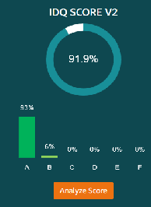
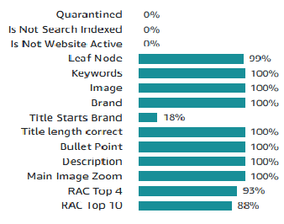
ASIN
Product Type
Title
Marketplace
Catalog Defect
Merchant Action
运营人员
完成情况:
具体类目缺陷，Missing A+，Relevant attributes ranked [5..10] are incomplete
Top 10 relevant attributes are not identified 对应商家动作是Assign eligible PT and fill in relevant attributes ranked [1..10]
Fill in missing relevant attributes ranked [5..10]: maximum_current, item_weight

